Fundamental Fitness Boot Camp

January 6, 2020
Monday – Friday
5:15 a.m.
Evening Session To Be Determined
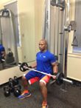

Phone: 501-772-0795
E-mail: tgfitness@gmail.com
Sign up at the Jacksonville Community Center
T.G. FITNESS FACTORY
Expert Rating Master Trainer Certified Weight Loss Specialist
Fitness Is Fun-damental
- Build Muscle
- Boost Metabolism
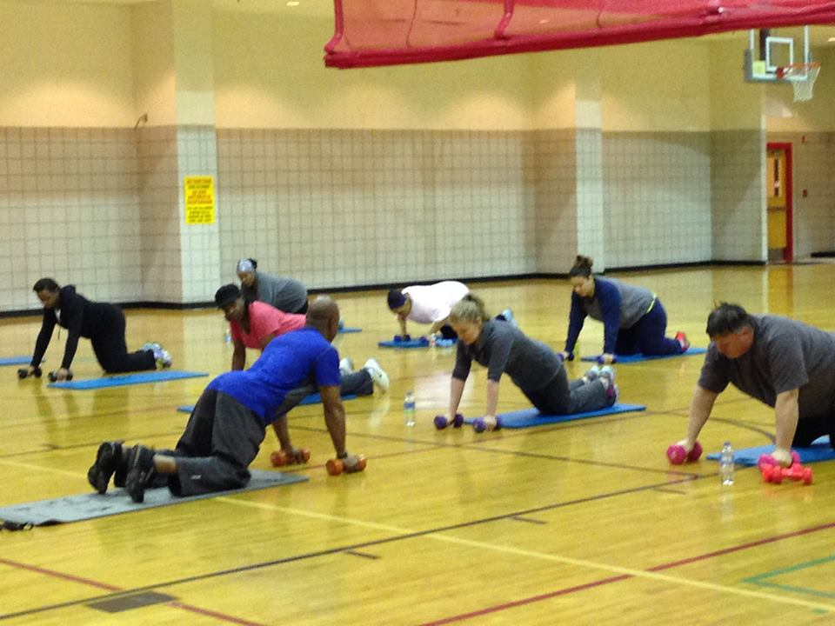
- Burn Fat
Fitness Is Fundamental
Fitness Is Fundamental

